Detailed information and reservation methods of the specialized facility Gabčíkovo - STU in Bratislava (hereinafter only specialized facility Gabčíkovo)

A student who arrives from a country that is currently not on the list of safe countries is obliged to register in the state COVID PASS system at https://korona.gov.sk/ehranica/# before entering to the territory of the Slovak Republic.

- Home isolation in specialized facility Gabčíkovo can be carried out only from September 7th, 2020 and it is mandatory until a negative result of the RT-PCR test for COVID-19 is obtained.
- The student is obliged to undergo laboratory diagnostics for COVID-19 disease no earlier than on the fifth day of isolation. If the test result is positive, then the home isolation continues, and it is necessary to follow all instructions of the relevant Regional Public Health Authority. If the result of the test is negative, then the home isolation ends, and the student can stay in the dormitory where was allocated accommodation.
- Upon arrival from the home isolation to the student dormitory where was allocated accommodation, student shall submit a confirmation of a negative RT-PCR test for COVID-19 taken in the territory of the Slovak Republic
- Student is obliged to pay a fee for the provision of home isolation in the specialized facility Gabčíkovo for:
- accommodation services per person / night - EUR 4.00,
- all-day meals (breakfast, lunch, dinner) per person / day - EUR 13.00,
- service payment „Full central safety service, n. o“ which provides specialized facility Gabčíkovo all services related to logistics, student stay and internet fee - EUR 50.00 per person for the entire stay in the facility.

- Student who wants to carry out home isolation in specialized facility Gabčíkovo must send the following data to the e-mail address: cpcus@euba.sk at least 3 working days before arrival:
  - name and surname,
  - address of permanent residence,
  - date and estimated time of arrival.

- Student can carry out home isolation in specialized facility Gabčíkovo only if student has its reservation confirmed in advance by e-mail and makes a reservation by 12.9.2020 with the last possible entry into the facility from 15.9.2020.
- Transport to the specialized facility Gabčíkovo and return from specialized facility Gabčíkovo to the student dormitory will be provided by the student individually at his own expense.
- Student must pay the payment for accommodation and catering services in cash after the end of stay at the reception of specialized facility Gabčíkovo.

Please note that obtaining a negative test will require approximately 9 days of home isolation.

The current list of safe countries is published on the website of the Regional Public Health Authority of the Slovak Republic www.uvzsr.sk or on the website of the Ministry of Foreign and European Affairs of the Slovak Republic www.mzv.sk. It is necessary to monitor the up-to-date list of safe countries before the student's arrival to the territory of the Slovak Republic.

Transport connections Bratislava - Gabčíkovo: https://www.sadds.sk/sk/cestovny-poriadok

Address of specialized facility Gabčíkovo: Dunajská 1352/93, 930 05 Gabčíkovo GPS coordinates: 47 ° 53'08.5 "N 17 ° 33'50.8" E ubytovanie.gabcikovo@stuba.sk Tel .: + 421 947 482 222

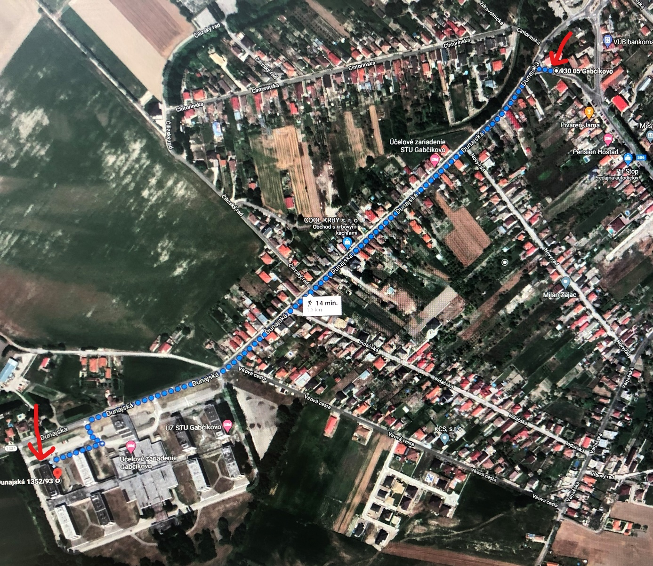
Picture n. 1 shows the road from the centre of Gabčíkovo to specialized facility STU Gabčíkovo (it is not possible to use public transport). The reception of the specialized facility Gabčíkovo will be working from 7.9.2020 to 16.9.2020 from 8.00 AM. until 8 PM.

