Ichiro Fujisaki

May, 2016

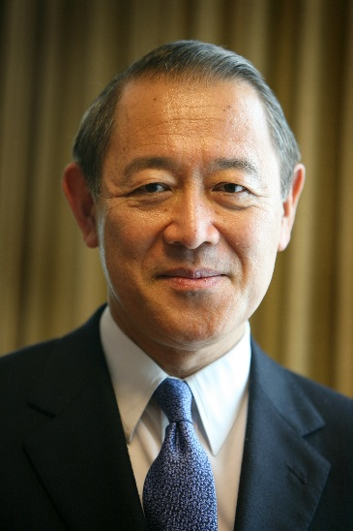
President, The America-Japan Society
Chairman of Institute of International Relations, Sophia University
Board member and advisor of several companies

2008-2012 Ambassador of Japan to the United States
2005-2008 Ambassador of Japan to the UN and WTO in Geneva
2002-2005 Deputy Foreign Minister
1999-2002 Director General for North American Affairs
1995-1999 Political Minister, Embassy of Japan, Washington DC
1994-1995 Deputy Director General for Asian Affairs

Entered the Foreign Ministry in 1969. Other than headquarter posts, served in the Ministry of Finance, Jakarta, Paris and London.
Studied at Keio University, Brown University and Stanford Graduate School.
Wife Yoriko and two daughters.

